
American International University- Bangladesh (AIUB)
Faculty of Engineering
Data Communications Lab

Course Name: | Data Communications
Course Code: | CoE 3201 | Section: | L
Semester: | Spring 2024-25 | Group No: | 08
Assignment Name: | Open Ended Lab
Assessed CO5: | Accepts and recognizes the role of shift keying (ASK) and multiplexing (FDM) to communicate binary bits as analog signals through multiple channels in society, health, safety, legal and culture.
Assessed POI: | P.f.1.A3
Serial | Student ID | Student Name
01 | 22-46175-1 | MD. MIRAN HOSSAIN
02 | 22-48483-3 | FAHMIDA RAHMAN
03 | 23-50194-1 | MOHSIN IBNA HOSSAIN
04 | 23-50187-1 | MD. YEAHYEA JAM
05 | 23-51354-1 | HOSSAIN MOHAMMAD SAMI
Mark distribution (to be filled by Faculty):
Objectives | Proficient [10-8] | Good  [7-4] | Needs Improvement [3-1] | Secured Marks
Depth of knowledge displayed through  appropriate  research  (P1) | Student was able to apply indepth engineering knowledge achieved by appropriate research about digital/analog communication to design the communication model correctly and fulfilled all design criteria. | Design process is not completely supported by in-depth engineering knowledge achieved by appropriate research about digital/analog communication, some but not all of the design criteria are fulfilled. | Design process contains mistakes and does not display enough indepth engineering knowledge achieved by appropriate research about digital/analog communication. Most of the design criteria are not fulfilled.
Depth of analysis  (P3) | Student defended the diversified approach taken to solve the problem with welljustified in-depth analysis that demonstrated abstract thinking. | Student’s attempts to analyze the diversified approach taken to solve the problem is not enough in-depth, some of design choices do not demonstrate adequate abstract thinking and are not properly justified. | Student did not attempt any indepth analysis of the designed system and displayed no abstract thinking.
Level of integration of multiple sections of design for  solution of high-level  problem  (P7) | Student correctly identified all problems and successfully integrated the interdependent parts into a high-level design using a block diagram.  Block diagram was at best match with the given problem. | Student was able to identify some of the problems correctly and integrated the interdependent parts into a high-level design using a block diagram.  Some parts of the block diagram were not a good match for the given problem. | Student was able to identify only one/two of the problems correctly and could not properly integrate the interdependent parts into a high-level design using a block diagram.  Only one/two blocks were correct and/or block diagram was incomplete.
Comments: |  |  | Total Marks (Out of 10):

Title
Accepts and recognizes the role of shift keying (ASK) and multiplexing (FDM) to communicate binary bits as analog signals through multiple channels in society, health, safety, legal and culture.

Abstract
This experiment is designed to

- To understand the fundamental concepts of digital modulation and multiplexing, this experiment explores how Amplitude Shift Keying (ASK) is used to convert binary data into analog signals, and how Frequency Division Multiplexing (FDM) allows multiple signals to be transmitted simultaneously over a shared communication channel.

- To develop a practical simulation using MATLAB that demonstrates the conversion of two digital signals into analog ASK-modulated signals, combines them using FDM, and then successfully demultiplexes and demodulates the composite signal to recover the original binary data streams.

Introduction

Modern communication systems rely heavily on techniques that efficiently transmit multiple signals over shared channels. ASK is a digital modulation technique that conveys data by varying the amplitude of a carrier wave, while FDM allows the simultaneous transmission of multiple signals over distinct frequency bands. This lab aims to simulate these concepts to understand their integration and performance in data communication systems. Understanding these fundamental processes is crucial for developing efficient, scalable, and secure communication infrastructures.

Purpose

The purpose of this experiment is to simulate a digital-to-analog communication system using ASK for digital modulation and FDM for signal multiplexing. The tasks include:

- Converting two binary signals (S1 and S2) to analog signals via ASK.
- Multiplexing the ASK signals into a single composite signal using FDM.
- Demultiplexing the signal and applying ASK demodulation to retrieve the original binary streams

Procedure
- Generate two binary signals (S1 and S2).
- Perform ASK modulation on both signals using separate carrier frequencies.
- Apply FDM to combine the two ASK signals into a single composite signal.
- Transmit the composite signal.
- At the receiver end, perform frequency filtering to separate the signals.
- Apply ASK demodulation to retrieve the original binary data from the filtered signals.
- Validate the accuracy of the received signals by comparing them to the original inputs.

Results
Performance Task for Lab Report
- Convert multiple Digital data S1 and S2 (as binary bits) into Analog signals using Amplitude shift keying (ASK)
- Multiplex the multiple Analog signals using Frequency Division Multiplexing (FDM) produce a composite signal
- De-multiplex the composite analog signal back into individual analog signals and perform the ASK demodulation to recover S1 and S2 digital signals
Code:
clc; clear; close all;

%//%// Parameters
S1 = [1 0 1 1 0 0 1 0];
S2 = [0 1 0 0 1 1 0 1];

bit_rate = 1; %// bits per second
bit_duration = 1 / bit_rate; %// duration of each bit
fs = 1000; %// Sampling frequency
t = 0:1/fs:bit_duration-1/fs; %// Time vector for one bit

f1 = 10; %// Carrier frequency for S1
f2 = 20; %// Carrier frequency for S2

%//%// ASK Modulation
ASK1 = [];
ASK2 = [];

for bit = S1
carrier1 = cos(2*pi*f1*t);
ASK1 = [ASK1, bit * carrier1];
end

for bit = S2
carrier2 = cos(2*pi*f2*t);
ASK2 = [ASK2, bit * carrier2];
end

%// Composite time vector
T_total = length(S1) * bit_duration;
tt = 0:1/fs:T_total - 1/fs;
%//%// Optional: Plot Filtered Signals

%//%// Frequency Division Multiplexing (FDM)
FDM_signal = ASK1 + ASK2;

%//%// Bandpass Filter Design for Demultiplexing
%// Filter for S1 (centered at f1)
bpFilt1 = designfilt('bandpassiir', 'FilterOrder', 8, ...
'HalfPowerFrequency1', f1 - 5, 'HalfPowerFrequency2', f1 + 5, ...
'SampleRate', fs);

%// Filter for S2 (centered at f2)
bpFilt2 = designfilt('bandpassiir', 'FilterOrder', 8, ...
'HalfPowerFrequency1', f2 - 5, 'HalfPowerFrequency2', f2 + 5, ...
'SampleRate', fs);

%// Apply the filters
ASK1_rx = filtfilt(bpFilt1, FDM_signal);
ASK2_rx = filtfilt(bpFilt2, FDM_signal);

%//%// ASK Demodulation
S1_demod = [];
S2_demod = [];

for i = 1:length(S1)
idx_start = (i-1)*length(t) + 1;
idx_end = i*length(t);

%// Demodulate S1
seg1 = ASK1_rx(idx_start:idx_end);
ref1 = cos(2*pi*f1*t);
prod1 = seg1 .* ref1;
avg1 = mean(prod1);
S1_demod = [S1_demod, avg1 > 0.2];

%// Demodulate S2
seg2 = ASK2_rx(idx_start:idx_end);
ref2 = cos(2*pi*f2*t);
prod2 = seg2 .* ref2;
avg2 = mean(prod2);
S2_demod = [S2_demod, avg2 > 0.2];
end

%//%// Display Results
disp('Original S1:');
disp(S1);
disp('Recovered S1:');
disp(S1_demod);

disp('Original S2:');
disp(S2);
disp('Recovered S2:');
disp(S2_demod);

%//%// Optional: Plot Filtered Signals
figure;
subplot(5,1,1);
plot(tt, ASK1);
title('Signal for S1');
xlabel('Time (s)');
ylabel('Amplitude');
grid on;

subplot(5,1,2);
plot(tt, ASK2);
title(' Signal for S2');
xlabel('Time (s)');
ylabel('Amplitude');
grid on;

subplot(5,1,3);
plot(tt, FDM_signal);
title('FDM Composite Signal');
xlabel('Time (s)');
ylabel('Amplitude');
ylim([-1.5,1.5]);
grid on;

subplot(5,1,4);
plot(tt, ASK1_rx);
title('Demultiplexed Signal for S1');
xlabel('Time (s)');
ylabel('Amplitude');
ylim([-1,1]);
grid on;

subplot(5,1,5);
plot(tt, ASK2_rx);
title('Demultiplexed Signal for S2');
xlabel('Time (s)');
ylabel('Amplitude');
ylim([-1,1]);
grid on;

Result:
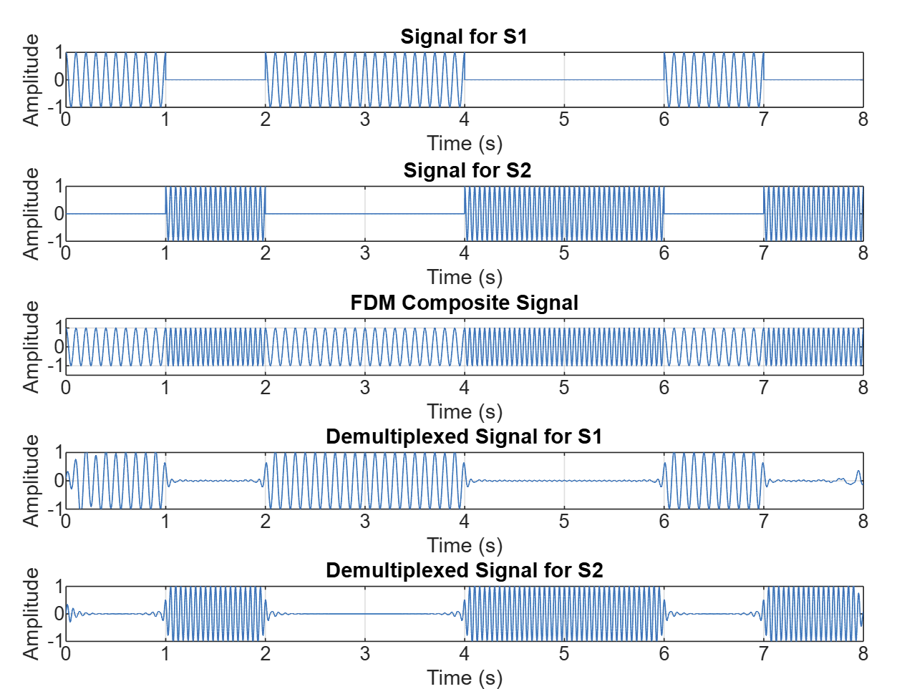
Fig1: Original Signal & Recovery Signal
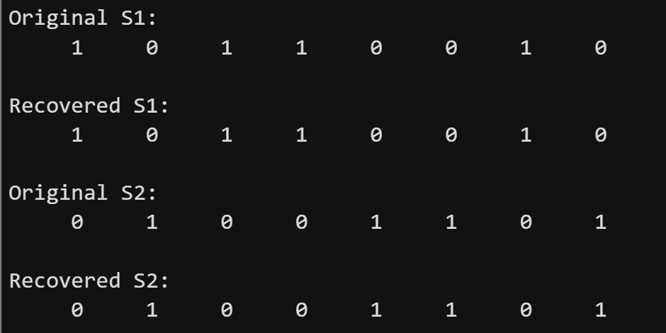
Fig2: Signal Recovery

Impact on Society, health and safety
- Society: Efficient communication systems powered by ASK and FDM enable high-speed internet, mobile communications, and broadcasting. This supports global connectivity, information sharing, and digital economies.
- Health: Wireless medical monitoring devices use similar communication techniques to transmit patient data in real time, enhancing healthcare delivery.
- Safety: Reliable communication protocols are critical in emergency systems (e.g., 911 networks, disaster response coordination), ensuring accurate information transfer and rapid response.
- Culture: Digital media streaming services benefit from multiplexing, making cultural content more accessible globally.

Discussion and Conclusions
This lab effectively simulated a simplified digital communication system using ASK and FDM. The experiment illustrated how digital signals can be transmitted over analog mediums, enabling multi-user communication. While MATLAB provides a controlled simulation environment, real-world systems may encounter noise, interference, and synchronization issues. Limitations included ideal filtering and perfect synchronization assumptions. However, the exercise enhanced understanding of key communication techniques and their societal implications. Future work can include implementation with noise and error correction protocols.

Reference

- Haykin, S. (2001). Communication Systems. John Wiley & Sons.
- Proakis, J.G., & Salehi, M. (2007). Digital Communications. McGraw-Hill.
- MATLAB Documentation - Signal Processing Toolbox. Retrieved from: https://www.mathworks.com/help/signal

